Techniques to manage anxiety

It is OK to be anxious, but it is what we do with the anxiety that is important.

What is anxiety

Anxiety is a feeling of apprehension or worry about situations in our lives. Anxiety is a safety response, a built-in survival mechanism which helps us to deal with stressful situations. This is called our ‘flight’ or ‘fight’ response, where we react to the situation either by running away from it or by staying and tackling it.

This is a normal, usually controllable, reaction for the unknown which usually settles down. Sometimes this normal reaction, and the feelings associated with it, are triggered frequently and can become out of control, turning into a vicious cycle of ever-increasing breathlessness and anxiety, each problem very much feeding the other.

What can I do to help myself.

Hand-held fan This technique can help to reduce the feelings of anxiety and breathlessness and give the sensation of getting more air in, thus aiding relaxation. The air produced by the fan stimulates small nerve receptors in the face which in turn stimulate the brain to slow down the rate of breathing. The fan should be held approximately 15cm (6 inches) from the face

Window breathing

1. Place your finger on the ‘dot’ in the top left of the rectangle.
2. Breathe in as you follow the line in the direction of the arrow to the next corner.
3. Then breathe out along the next side.
4. Continue around the rectangle following the instructions. Breathe Out Breathe In Breathe Out

This breathing technique is helpful for getting your breathing into a more rhythmical pattern (breath in slightly shorter than your breath out). It is also very helpful as a distraction technique for when you have an episode of breathlessness or anxiety.

The Tapping techinque

Use the pads of your fingers tap

3 times on each point.

Repeat as required.

3 Breathes

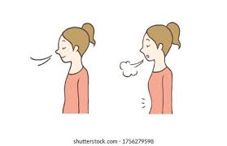Breathe in through your nose for 3 counts 1,2,3

Hold the breath for 3 counts 1,2,3

Breathe out through your mouth for 3 counts 1,2,3

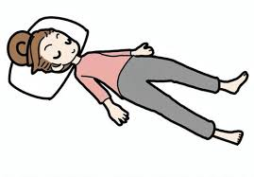Body Scan

It can often feel like we’re an observer of our own body caught up in our heads.

Spend your one mindful minute bringing awareness to your body and your body’s sensations.

Close your eyes and begin scanning your body.

Start with your feet, and then slowly bring your awareness upwards in your body until you reach your hands.

What sensations do you feel? Heaviness in the legs? Strain in the back?

Perhaps no sensations at all. Now move your focus out from the hands and become aware of your environment and the space all around you.

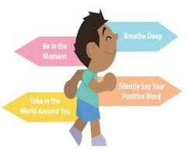Mindful walking

is something you can practise at any time as you go about your day.

Walk slowly: become aware of the sensations in the soles of your feet as they contact the floor, and any sensations in the muscles of the legs. You don’t have to look down at your feet.

When your mind wanders, use the contact of the feet on the floor as an anchor to bring you back into the present moment.

Just take a minute to focus on the sensations generated by walking.

The ‘calming hand’ technique

This is an easy technique and can be used at any time as we always have our hands with us.

1. Hold your thumb firmly and recognise the signs of your anxiety. 2. Hold your index finger, relax your shoulders and sigh out. 3. Hold your middle finger and take a slow deep breath in. 4. Hold your fourth finger and gently breathe out. 5. Stretch your hand and relax. Repeat as necessary.