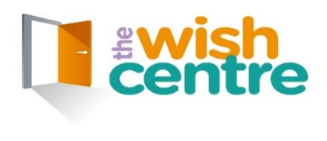

Children’s Data Privacy Notice
We want to make sure you feel safe, happy, and supported. To do that, we sometimes need to know certain things about you. This notice explains what information we collect, why we collect it, how we keep it safe, and what your rights are.

What Information We Collect
We may need to know things like:
- Your name
- Where you live
- When you were born
- Your phone number or your family’s phone number

Why We Collect Your Information
We collect this information so we can get to know you better and make sure we can contact you when needed. We only collect what we truly need to support you.

Who We Share Your Information With
We do not share your details with anyone unless you tell us we can or we must by law to help keep you safe. Examples include teachers, doctors, or social workers.

Your Rights
- 📘 Right to be informed
You can ask how we use and store your information.
- 👀 Right to see your information
You can ask to look at the information we have about you.
- ✏️ Right to change information
You can ask us to fix anything that is wrong.
- 🗑️ Right to have information removed
You can ask us to delete information we no longer need.
- 🙅 Right to say no to recording
You can tell us not to record information, but this may affect how we support you.
- 📤 Right to get a copy
You can ask for a copy in a format that is easy to use.
- ⛔ Right to object
You can say you don’t want your information used in a certain way.
- 🤖 Right to avoid automated decisions
You can say no to decisions being made automatically about you.

Any Questions?
If you are unsure about anything or want to know more, just ask! We are always here to help.

