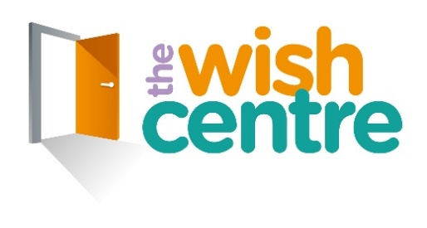

THE WISH CENTRE: Our Impact Report

Growth and development 2011-2021

March 2022
CONTENTS
 | CEO Introduction | 3
 | Chair Introduction and Context | 4
 | Acknowledgements | 5
 | Values & Objectives | 6
1 | Our Work & Impact | 7
2 | Strategy & Growth | 16
3 | Corporate Strengths | 21
4 | The Future & Challenges Ahead | 27
5 | A Survivors Letter | 28
 | Appendix
 | Methods | 29

CEO INTRODUCTION
Sometimes it’s good to lift your foot off the accelerator, take stock of how far you’ve come and reflect on how you got there. In this Impact Report we have tried to take this long view. We look back over the last decade and consider the journey the Wish Centre has taken over this time, highlighting some key developments with some reflections on how things have changed along the way.
This report doesn’t attempt to replicate our regular annual report which will set out the key stats and details specifically for the latest financial year 2021/22. Similarly, the Impact Report takes a step back from the normal report cards we routinely submit each year to our funders and commissioners on individual project performances and activities.
Our team has done some incredible work over the last 10 years and more. I’m so proud of how they have consistently met any challenge and dedicated their whole efforts to support all our clients with compassion, innovation and determination. The impact of their work has never been in doubt and I could not be more proud of each and every staff member and volunteer.
Organisationally, the Wish Centre is quite a different organisation today compared with its 2011 counterpart. While its charitable objectives and commitment to the sector remain the same and undiminished, its scale, structure, operational methods and activities have developed and broadened out of recognition over this time. We are hugely proud of our “whole family” approach, something that is still rare in the domestic abuse arena, and something we have nurtured and grown over the last decade.
This report identifies some of the key changes and with the benefit of hindsight (always a useful commodity!) also some reflections on the strengths and impacts these developments have produced.
As in life, the changes have followed a cycle of ups and downs. The path the Wish Centre has followed over the last 10 years has not been an undeviating upward arrow. Rather it has been a cycle of successes tempered by the occasional loss, obstacle or step sideways. Our organisation is all the stronger and more mature for it. But the unchanging feature through all this has been the positive impact we have been able to make on the lives of our clients, their families and our commitment to them.
Shigufta Khan - Chief Executive Officer, the Wish Centre
Contact:
Shigufta.Khan@thewishcentre.org
Tel: 0300 561 0440
Unit 21 Business Development Centre, Eanam Old Road, Blackburn, BB1 5BL

CONTEXT & CHAIR INTRODUCTION
This Impact Report marks out some of the key changes and developments in the work of the Wish Centre and how it has operated as a grassroots domestic abuse charity over the last 10 years. It has been a privilege to have served as Chair during these years and indeed my links with the Centre go back to its very humble beginnings back in 1989.

The organisation is a very different entity now compared with those days. And the changes in the main have been organic, developing as circumstances, need and resources have allowed. In some cases we have confronted major and sudden challenges but I can proudly say we have met them all and flourished, thanks in no small part to our wonderful staff team and volunteers.
I think the evidence of experience and perspectives contained in these pages is particularly valuable, coming from a frontline local charity and we welcome feedback from those reading the report. Hopefully, the findings and observations will ring true with others across the sector and I believe there are some features which are more widely applicable for healthy organisations in general.
Always being faithful to our mission and objectives to support those affected by or fleeing from domestic abuse, our ultimate goal has been brilliantly summed up by a recent quote from a service user who on leaving the Centre, commented:
“I feel strong and empowered.” Service user
In structuring reports like this, there can be a temptation to place “case studies” at the end in an appendix. We’ve put our case studies throughout the report, they are the heart of it. They are not an afterthought. We have given them the prominence they deserve, illustrating the pain that individuals have endured, along with their journeys to safer and better lives with a little help from us.
We have also decorated the report on various pages with quotes given to us by different service users over recent years which hopefully brings to life some of the impact we have made.
For symmetry, we have also book-ended the report with a letter written by one of our amazing survivors who describes her experiences of being supported by the Wish Centre so movingly.
Pauline Geraghty MBE – Chair, the Wish Centre

ACKNOWLEDGEMENTS
We look back with pride over the last 10 years and thank all our supporters who have continued to make our work possible over this time. These include all our staff, volunteers, trustees and also our service users.
None of this work would have been possible without our many funders, large and small, who have given generously their time and resources to the Wish Centre so that we can carry out our mission as a grassroots charity to support victims and families affected by domestic abuse.
Special appreciation must go to our major local commissioners of services, Blackburn with Darwen Council, Lancashire County Council and the Lancashire Office of the Police and Crime Commissioner whose support has been immense and highly valued, as ever. Local support from community members, local agencies, groups and businesses has also been fantastic.
Finally, thanks go to our staff team who contributed their time, information and thoughts to this study and on whose reflections it is based. These are:
- Robyn Ashfield
- Pauline Geraghty
- Lynette Hatton
- Shigufta Khan
- Anna Leicester
- Barbara Martin
- Debbie Springham
- Rebekah Wilson
The fault for any errors or omissions lies solely with the author with his apologies.
Bob McDonald, Independent Consultant for the Wish Centre

VALUES AND OBJECTIVES
Our values are integral to how we work with clients, stakeholders, funders and partners. They underpin everything we do. Our objectives are what we have worked towards achieving for a decade and what we continue to strive for today and in the future.

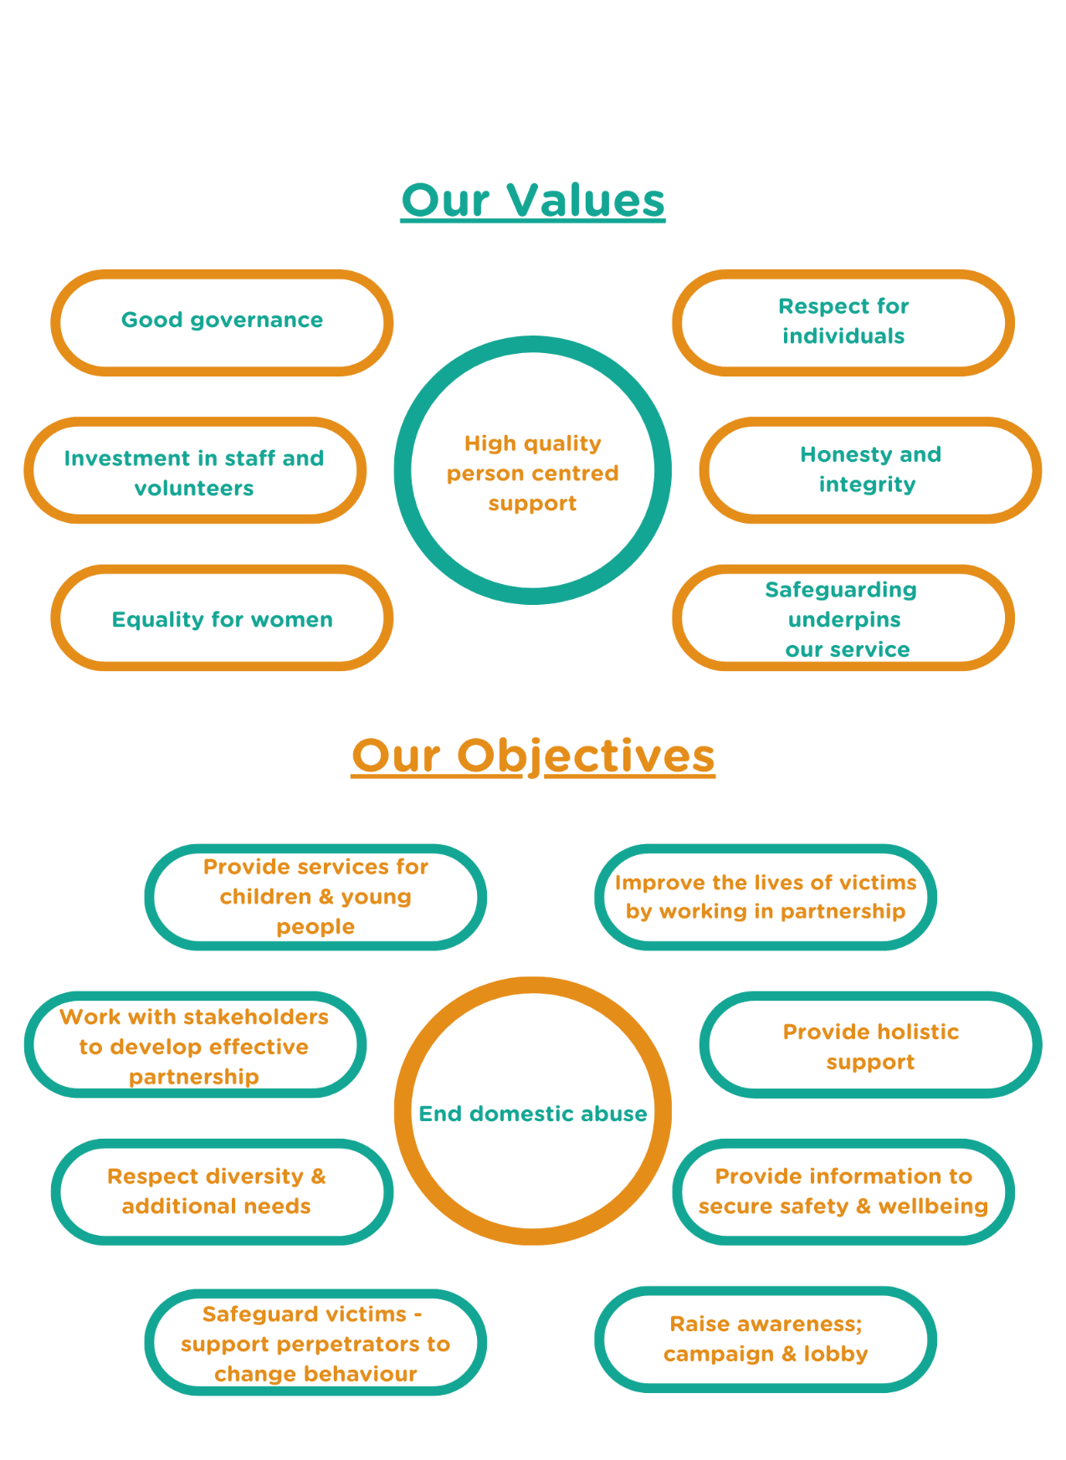

- OUR WORK & IMPACT

Stats and data aren’t the whole story. Behind the numbers lie a number of changes and developments over the years which collectively have steadily transformed the Wish Centre, its performance, range of provision and impact on the lives of those we support.
In this section we look at some of the main changes and features which have defined and influenced the Centre’s development. Information and insights have been provided by a core group of senior managerial staff who themselves work on the frontline, have been with the Wish Centre for many years now and have witnessed its journey and changes over the last 10 years.

The nature of domestic abuse has changed
Staff commented on how the challenge of supporting victims of domestic abuse has become significantly more difficult at the end of the decade compared with its beginning. There has been an increase in vulnerabilities in the victims they see with more clients struggling with their mental health and food poverty (even if they are in employment) than ever before. This trend has been compounded at the same time by a decline in statutory mental health services.

“I was initially in a very dark place with everything that was going on around me and felt very low.” Female service user.
Staff also noted that women are presenting with different levels of vulnerabilities than previously and this has become especially marked over the last 4 years. Staff commented on how victims’ initial fears and need for security can be addressed promptly and effectively but their ongoing mental health needs are much greater these days and have demanded ever higher levels of competence and management by staff.
“The biggest shift I’ve noticed has been the way DA has itself changed over the last 10 years which means that the challenges we face now have become all the greater. The nature of risk has changed massively.” Refuge manager.
The use of new technology has broadened the spectrum of risk (social media, location and tracking devices and the modern habit of sharing pictures online) which has in turn added to the burden and challenge for staff to manage the behaviour and the heightened and ever-present risk now faced by victims.
“DV has changed and got worse.” Staff member
“I now understand that I was abused and in understanding that I feel I can now work toward moving on.” Female service user

Victim Services
The Wish Centre has naturally always had a very strong victim focus and a tradition of working with all-risk level cases and crisis care. The Wish Centre is imbued with the ethos that no-one is turned away. This characteristic of working with low, medium as well as high risk cases was proclaimed by staff as a distinguishing characteristic of the Wish Centre, compared with many other DA services in the sector.
“I just wanted to say how wonderful the Wish Centre is and how brilliant the programmes are.” Service user
Services and support have consistently been maintained around advice, continuous risk assessment and safeguarding, safety planning, sanctuary, IDVA support and therapeutic group programmes, AIM and the Recovery Toolkit. These have also been strengthened by counselling in recent years.
“We have always had a strong and dedicated staff ethos here.” Staff member
The Wish Centre has consistently had good relationships and links with other agencies and services locally. And the charity redoubled those efforts during the middle years of the decade when it did not have the status of commissioned service to fall back on.
We made a conscious effort to build our community profile and sustain self-referrals, and thereby continuing to meet the needs of its service users.
“I feel happy that there is a service out there who really understood me and you showed me so much empathy throughout.” Service user.
The victim support has now developed further in the decade and the IDVAs role has become more streamlined, as part of a bigger staff team with good transferable skills, boosted by the recovery of the local authority commission for Blackburn with Darwen in 2019.
With the growth of strengthened and supporting work with children, young people, and with perpetrators, staff teams are well integrated with good interaction, both formal and informal. Across the charity, Covid triggered new models of working including support for victims where the necessary changes enabled more people to engage with the whole process.
These have all been key features in the growing quality and consistency of the Wish Centre’s support and recovery work with victims over the last 10 years.
Tina’s Story
Tina self-referred to the Wish Centre when she had recently moved into our area to stay with family as a consequence of suffering domestic abuse and is a good example of how we have been able to support her needs, recovery and see her in a much more positive position from which she and her children can move on.
She had 3 children removed and now was engaged in court proceedings to regain parental responsibility for her new baby. The local authority (out of area) was advising against the return of the child with Children’s Services losing trust in Tina as she had withheld information from them that compromised the children’s safety. When we initially started to support Tina, she was not accepting responsibility and instead blaming agencies, minimising the abuse and the impact on her children of living with and witnessing abuse.
“…she began to accept responsibility for the choices she has made…”
We supported Tina with housing and then engaged her on our therapeutic programmes. Tina started to attend AIM (Awareness Insight Motivation) Programme. Tina settled well into the group and was very open and honest. She began to accept responsibility for the choices she made and the impact of these choices on her family, particularly her children. Tina was able to demonstrate a sustained change in her behaviour. She started to work with professionals, grew in her confidence following the programmes, engaged in counselling and this led to her social worker supporting her and advising a planned return of the baby.

Refuge – meeting the challenge of increased need
The Wish Centre manages two refuges and has provided safe temporary accommodation and support at a high standard for female victims of abuse and their children over the last decade and, indeed, from the organisation’s very beginnings over 30 years ago.
The annual throughput of residents in refuge has remained consistent across the decade, with a limit capped by the physical space available. In the 10 years since 2011/12 the combined numbers of women and their children accommodated in refuge have ranged annually from 97 to 150, at an average of 127 women and children per year. The length of stay in refuge varies according to individual circumstance and need.
“You have treated me with respect, kindness and belief. Your passion and dedication has really stood out to me and has been integral in getting me to where I am today.” Female service user
Two features stand out from the reflections of senior refuge staff on the changes and developments they have seen over the last decade. First, the huge efforts needed by refuge (and the wider Wish Centre) to meet the changing needs and vulnerabilities of victims; and second, the ongoing development and integration of services across refuge and the Wish Centre as a whole.
The workload on Refuge staff has become much greater than previously and is a product of the much more highly challenging DA environment which staff are faced with today.
“The job has grown immensely.” Staff member
Our report alluded earlier to the increases in complex needs, the changing nature of risk and how the nature of abuse itself has got worse: a decade ago children may have witnessed DVA – and today Refuge staff comment that more children have experienced it directly themselves.
The ongoing mental health needs of victims in refuge have become greater today and involve ever higher levels of competence and management by staff. Mental health services struggle to meet demand adequately; and refuge staff have noticed the raised thresholds of getting children opened by the statutory providers. The impact on Refuge is immense.
Angela’s Story
Angela and her children were referred to Refuge as their location in another refuge had been discovered by her perpetrator and was therefore unsafe. On arrival with us, they were all quite apprehensive, afraid and not very confident. Staff therefore reassured the family that they would be safe here and fully supported throughout their stay.

Wrap around support was immediately provided from the first day. This included being shown around the property, given a welcome pack, including some food and toiletries and admission paperwork completed. Angela and her children were registered with a GP, Dentist and the Health Visitor. The two older children were registered for school places and the younger child registered for a nursery place. Staff also assisted the resident in changing her address with all relevant external agencies.
A risk assessment and safety plan were completed with Angela by one of our IDVAs and a comprehensive Support Plan tailored to the family’s individual needs. Angela has been supported by the Police, Solicitors, Children’s Social Care, The Benefits Agency and Housing.
During their stay in the refuge both Angela and her children have received weekly support from Refuge Support Workers and the Children’s Workers and they have grown in confidence.
Angela and the children attended key awareness courses such as AIM and You and Me, Mum; along with peer-to-peer sessions to make new friends and take part in several activities without their children. The children have started school and nursery and regularly attend children’s activities. The children and their mum have also gone on outings to the park with staff and other residents.
Ten months later the family is in a much better position to move on from Refuge. They will be able to continue to receive support as/when required from the Wish centre.
“The biggest change boils down to the fact that refuge staff are having to deal with issues which previously had been picked up by mental health services and crisis teams.” Staff member
In practice, there has been an increasing reliance on the Third Sector in general before cases are opened by statutory providers. The problem and pressures on staff are compounded by the tendency for service users to stay in refuge for much longer (9 months plus is common), a feature which is commonly seen across the North West. This does not aid the recovery and rehabilitation of victims with the risk of refuge residents becoming over-dependent and institutionalised and their children overly (if understandably) attached to refuge staff.
“I feel ready now for the next chapter, with renewed confidence and excitement.” Service user
Demand on staff has also been increased by the trend in recent years for increased numbers of victims and families who are referred without any previous involvement or being known to services. This has increased the workload on staff to get a wider range of services involved to meet their needs.
In response to these latest pressures, the Wish Centre and refuge staff have redoubled efforts and the nature of support. This is integrated with other provision for women and children from the wider Wish Centre. It includes participation in the therapeutic group programmes (AIM and the Recovery Toolkit); in children’s programmes like Helping Hands, You and Me, Mum; and Drawing and Talking to address the needs of the children most badly affected and traumatised by the abuse they have experienced; and the opening of a counselling service in Refuge to help compensate for the lack of access to statutory services.
“It’s a measure of the impact we have made in how the Refuge team has responded to all the increased demands.” Staff member
Gaps are filled and support enhanced by as much local multi-agency working as possible, with other local voluntary groups such as Youth Zone being especially supportive; and by training up the Henry (parenting) programme which is certificated for mums and can be delivered one-to-one or in groups.
The various Wish Centre teams (victim support, IDVAs, children and young people, perpetrator team, volunteering and PR) are very distinctive but also well-integrated. They meet formally in scheduled meetings as well as on a needs basis, support each other well and avoid the traps of silo working in their specialities.
These are all the key factors which continue to transform the Refuge service and have such an enhanced impact on quality and impact of services and outcomes as the decade has progressed.
Laura’s Story
Laura began a relationship with Jim after her long-term partner had died suddenly. Jim seemed like the perfect man – kind, attentive, supportive and understanding. Within 6 months he had persuaded Laura to spend her life savings on buying a cabin by the sea, hundreds of miles from her friends and family. Within weeks Laura’s phone had been broken and she had become completely isolated. Emotional abuse was followed by physical abuse. Laura was made to sleep on the toilet floor regularly.

She was beaten and strangled to the point of being unconscious and she turned to alcohol as a way to try to cope with her fear. Laura had to escape with nothing when her partner left the house for a short time.

Laura had intensive support in our refuge for 2 months, was accompanied to alcohol misuse meetings, mental health appointments and her GP before we supported her to find her own home. She continued to receive support from our outreach team for a further 18 months and from our volunteers for 6 months.

Laura went on courses to build her self-esteem and then found herself in a classroom for the first time in 24 years. Laura now has a professional qualification, is in full-time employment, volunteers for a local charity and lives happily with her dog, Arthur.

Support for Children and Young People

In January 2020 we published a major internal review of the Wish Centre’s work supporting children and young people who have been affected by domestic violence abuse. This can be viewed via the hyperlink. It provides a comprehensive account of the range of support which the Wish Centre has built up over recent years, along with an outline of how damaging the impact of DA on children can be on their lives, their development and their health as they grow into young adulthood.
The report left in no doubt the scale of this problem and the impact on young lives.
“I’m starting to envision a positive future for myself and for my daughter.” Service user
The Wish Centre has steadily developed an imaginative portfolio of support programmes for children and young people to help them overcome the effects of domestic abuse. These include Helping Hands (focusing on protective behaviours); the Young People’s Recovery Toolkit (informed by trauma focused cognitive behaviour therapy); Expect Respect (supporting young people to manage conflict); and the Parachute programme which is aimed at young people who are perpetrating abuse themselves. These are age-appropriate, group programmes, with one-to-one support provided, where required and where resources allow.
Anne-Marie’s story
Anne-Marie, 10 years old, arrived with her family to refuge November 2018. The family came from the travelling community and at first mum would not allow her child to work with staff, we later found out this was due to taking this as an insult to her parenting due to cultural upbringing. After building a positive relationship with mum she gave her consent for us to do some work with her child.
Anne-Marie had not attended school regularly and had ADHD. Unfortunately, she had witnessed domestic abuse and this impacted her conduct during sessions. She joined us for a Helping Hands session and unfortunately her behaviour was inappropriate and she struggled to interact with her peers. Staff spoke to the young girl and explained that this was not acceptable behaviour and explained more about the sessions. Staff learnt that breaking information down and assisting Anne-Marie during sessions helped her to understand tasks and positively join in the sessions. Sessions focused around emotional health and wellbeing and domestic abuse awareness at a young person’s level of understanding. Tasks included working together to understand emotions and keeping safe.
Behaviour was managed by giving clear explanations to the young people in the group and making a list of rules together in the first session. As the sessions progressed Anne-Marie responded well and engaged positively with the Helping Hands programme and made some healthy relationships with others in the group. She successfully completed the Helping Hands programme.

We have also trained staff to deliver a one-to-one programme which uses “Drawing and Talking” as a child-centred therapy which can be used to deal with mental health issues and heal associated emotional pain. This is for children who have been the most badly affected and for whom group programmes can be too challenging and therefore inappropriate.
Demand for this support has grown over the decade with the number of children linked to referrals being 30% higher in 2021 than in 2011/12 and with children referred to programmes increasing 4-fold from 90 to 400 in this timespan.
Liam’s Story
Liam was referred to the Respect Young People Programme (RYPP) by a Family Support Worker because of his aggressive and challenging behaviour within the family home.
Liam lives with his parents and younger brother and the case was open on a CAF at the time of referral. Negative behaviour included assaulting both his parents and younger brother by punching them and causing extensive damage to the house by punching and headbutting walls and doors. He advised that his dysfunctional behaviour escalates when he is feeling annoyed with other people and his brother.
Sadly, Liam’s mother is unwell, and this results in periodic admissions to hospital which Liam finds difficult to cope with. Other support already in place included a Youth Engagement Officer, a child psychologist and a specialist Bowel and Bladder Nurse due to Liam struggling with soiling accidents.
“You have done so well in the sessions, even when we were talking about really tricky things.” RYPP worker to Liam.
A Wish Centre RYPP trained worker was allocated to Liam and a local authority staff member was allocated to work with the parents. Initially, both parents undertook the programme together with very positive outcomes for all. With Liam initially minimising his behaviour and trying to shift the blame, staff worked hard to reframe his thoughts and he really started to enjoy the experience whilst putting lots of effort into the ‘assertive communication’ and ‘conflict resolution’ work. Liam’s parents were duly made aware of this in order that they could support him in using these newfound skills. More recently, Liam has shown that he is able to take responsibility for his conduct and to recognise that he does not have to ‘win’ and that resolving conflict is a better outcome.
Liam’s school have been very supportive throughout and as the final session of the RYPP approaches, parents have reported an improvement in Liam’s behaviour with only one recent incident which was dealt with effectively using the Family Agreement established between Liam and Mum and Dad as part of the programme.

Work with children and young people has become a real specialism for the Wish Centre and has earned a well-deserved reputation, recently extending preventative work both with the Parachute Programme (helping young people handle their emotions) and the Respect Young People Programme (RYPP) working together on parent-child relationships with whole families across the whole of Lancashire.
Building up this portfolio of support for children and young people has been hard work. We have naturally welcomed commissioned work in recent years but for most of the decade as a charity we have had to fight for scarce competitive funding from charitable foundations and trusts. In many respects, notable exceptions aside, funders have traditionally prioritised their support for work with primary victims of DA and children have tended to miss out.
It has been a distinguishing feature of the Wish Centre’s work that we have been able to grow this area of work, overcoming the Pandemic challenges, now resurrecting our schools work and matching up provision with a sustained demand for our services.

Perpetrator Work
Perpetrator work may be unusual for most victim services but over the decade this has become an increasingly important dimension of the Wish Centre’s overall provision and forms a vital part of the charity’s “whole family approach” for addressing domestic abuse.
“I’ve come from a background of very, very strong beliefs, and everyone has changed me for the better. I’m leaving here a lot better man than when I first walked through the door.” Male service user
Behaviour change work with perpetrators started off in modest ways with limited sessional worker support along with some counselling input for some perpetrators who were likely to engage. This was followed by accelerated growth with the recovery of the Blackburn with Darwen Council commission in 2019. Perpetrator work was then expanded hugely by the successful tender for the County contract by Lancashire County Council also in 2019.
“We took a conscious decision to do more work with young perpetrators and to get in early.” Staff member
From being a very victim focused service, the Wish Centre now incorporates sustained and systematic support around perpetrators, children and young people. The main DA perpetrator programme run by the Centre is “Make the Change©” (MTC) which now carries the award for the national Respect accreditation standard. Provision is currently being enhanced by the offer of a two-session awareness raising programme; a less formal, drop-in “Be the Change” programme as a way of sustaining the progress made by MTC; along with partnership work in Blackpool (which as a Unitary Authority falls outside the County Council’s remit) to work with complex needs cases and offering holistic and ongoing support.
“We are a family now and it’s all because you helped me to get this far. Thank you.” Male service user
Stuart’s Story
Stuart was referred to The Wish Centre by Children’s Social Care because of concerns around his behaviour in previous intimate relationships.

At the time of being accepted for the Make the Change© perpetrator prevention programme, Stuart had been convicted of two domestic assaults involving his ex-partner and their young son. He was being supervised by the National Probation Service having been sentenced to an 18 month community order, 30 days rehabilitation activity and was to undertake a domestic abuse programme in addition to 120 hours unpaid work. Also, Stuart was to access an anger management programme whilst continuing to work in a fulltime sales position, being the sole income provider in his household.
Despite a ‘shaky’ start, Stuart quickly settled into the group programme which he accessed online, acknowledging his aim to change his behaviour around anger, his ability to empathise with others and address his use of cannabis. Facilitator feedback evidenced that Stuart was a positive influence within the group and was willing to reflect on his abusive behaviour and the impact of this on his ex-partners and his children.
As he put it, he had to come to terms with his previous experiences:
“and I cannot keep using my past as an excuse.” Male service user
Stuart has recently completed the 14 sessions programme; he is successfully working his way through his court order and has now begun his anger management programme. He continues to work full time and is supported by the local drugs and alcohol service in relation to his substance misuse. There have been no further reports of abuse. He has also volunteered to support The Wish Centre by agreeing to discuss the impact of the perpetrator prevention programme on his behaviour and on his aspirations for the future.
A crucial development and expansion has been the conscious decision to also prioritise prevention work with young perpetrators, “getting in early”. This has been exemplified by the Parachute Programme which works with children and young people up to 19 years old; and the Respect Young People Programme (RYPP) working with whole families across Lancashire, Blackburn with Darwen and Blackpool.
Natasha’s Family Story
The RYPP programme has been making a big difference to the relationship between parent and her daughter who had been referred by Children’s Social Care for being abusive towards Mum. The teenage daughter had a lot of anger and resentment towards Mum which had built up from her early childhood by her mother’s former alcohol and heroin addiction and when she had to (in her own words) “bring herself up”. Relations with her mum had been made the worse by her being repeatedly let down by her Dad, leading her to take the frustration she feels out on her mum.
“overall home life has massively improved…”
Mum has been sober for 5 years now and is now working really hard to better her life and all her daughters’ lives. When the family started RYPP, the communication between Mum and young person was hardly there, both of them admit that they perhaps didn’t listen to the other as much as they should and didn’t try to understand what the other person was trying to say.
Progress has been hard and the daughter has been using alcohol to ‘forget’ what has happened and to not feel anything. Mum is scared that her daughter is going to turn to ‘harder’ substances like Mum did in the past as she started drinking alcohol excessively first. She is involved with CAHMS to help her work through her trauma but the high turnover of CAMHS staff dealing with her case has undermined her trust and so now she expects professionals to leave. Having a consistent member of the Wish Centre team working with her and family has helped and both mum and the young person have seen a change in both of their behaviours, their relationship and communication has massively improved, as well as overall home life.

There have also been positive developments which have been driven by the Pandemic and the need to find ways to navigate round the restrictions on social contact and adopt remote delivery as a way of sustaining provision to service users.
“…this has opened up the way of thinking and working more imaginatively now…”. Staff member.
The circumstances and limitations arising from Covid-19 led to an overhaul of programmes and methods of delivery. By the end of 2019/20 client agreements had been modified and agreed; and working protocols revamped. It has also led to developing a pattern of working with smaller group sizes in a safe way.
A recent example of opening up more imaginative access has been the delivery of the MTC Programme online to an eligible man stuck in a European country at the height of the Pandemic.

- STRATEGY AND GROWTH

The human stories in our case studies, alongside our other work, sensitively illustrate how the Wish Centre has converted its priorities and strategic objectives into operational reality. The Centre’s latest Strategic Plan (2019-2022) identified the main objectives for this period which were reviewed and updated regularly with Trustees.

In 2022 the Plan reaches the final year of its current cycle and will now receive a major planned update. The Plan’s core objectives have provided anchors around which the organisation has designed, developed and delivered a range of services and support over this time. They are well represented both in the case studies throughout the report, as well as being reflected in the insights provided by the Wish Centre’s senior staff for this report about how the organisation has changed over the decade in their eyes.
Strategically, the organisation has pursued a consistent focus on four main objectives:
- To provide outstanding support and services to everyone who comes for help and support
This includes maintaining vital services for victims (e.g. Helpline, referral process, crisis support, residential accommodation, empowerment and education courses)
- To develop and enhance our services to meet increasingly complex issues
This includes research, review and develop bespoke services to meet needs
- To manage the charity effectively, investing in our people, brand and fundraising
This includes effective recruitment of staff and volunteers; service users helping develop services through consultation and co-production; fundraising; brand awareness locally and nationally and improved social media presence
- To campaign to raise awareness of the domestic abuse agenda, locally and nationally
This includes raising public awareness, specific campaigns, partnership work to lobby locally and nationally for improved domestic abuse provision
The Strategic development of the organisation and its impact, in line with these objectives, can also be seen in the upward trajectory of core performance statistics over the last decade. Output numbers only tell part of the story of impact but they still demonstrate a pattern of growth. Later in the report we dig under the surface of the statistics for more qualitative features behind the Wish Centre’s development and how it has changed over the decade.
Service Output Data
The following graphs chart the change in some of the core performance output data over the 10 years since 2011/12. The metrics illustrate the growth in demand for a variety of services and interventions provided by the Wish Centre over this time. The pattern overall is one of significant growth over all categories with the most influential and major factors being the expansion of our perpetrator work and some aspects of our young people’s work into Lancashire and Blackpool and, most recently, coping with the impact of Covid.
Total Number of Referrals into service
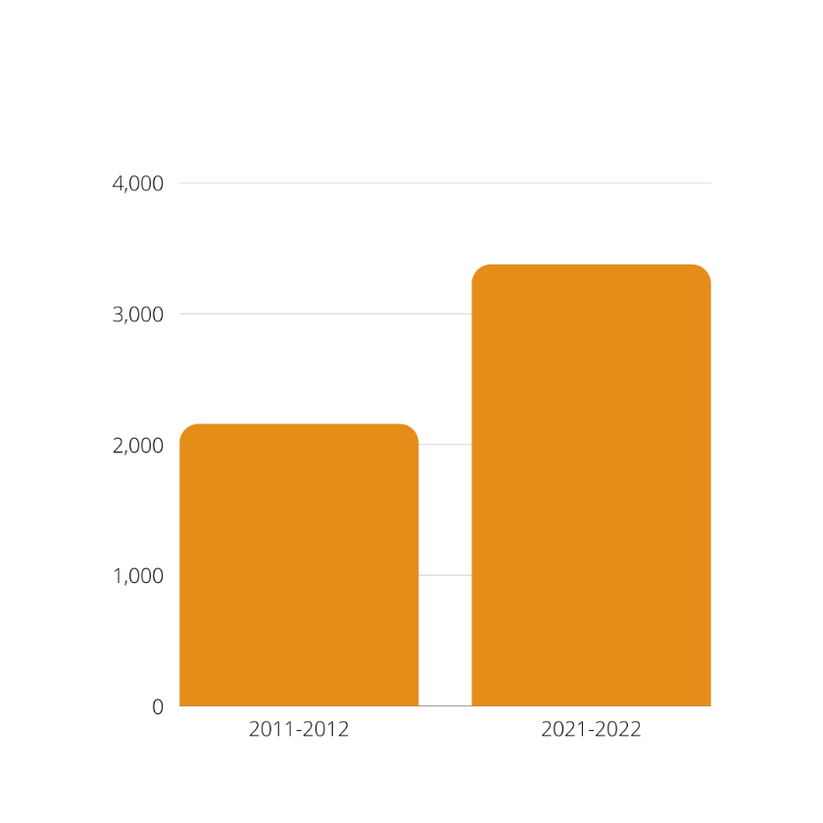
The growth in demand for Wish Centre services is significant and illustrates how the scale of the charity’s status and our activities have developed over this time. Referrals in 2021/22 were 47% higher than in 2011/12.

Total number of children associated with these referrals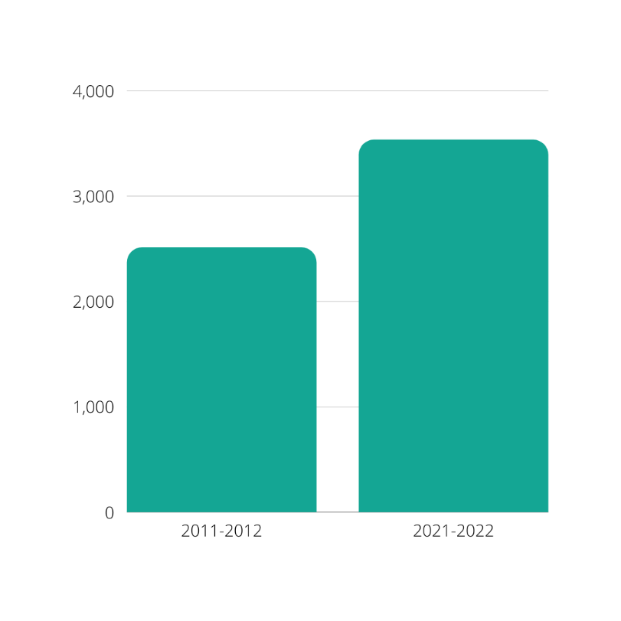
This is also reflected in the increase in the number of children linked to those referrals which were 30% higher in 2021 than 2011/12.
Total number of high risk referrals
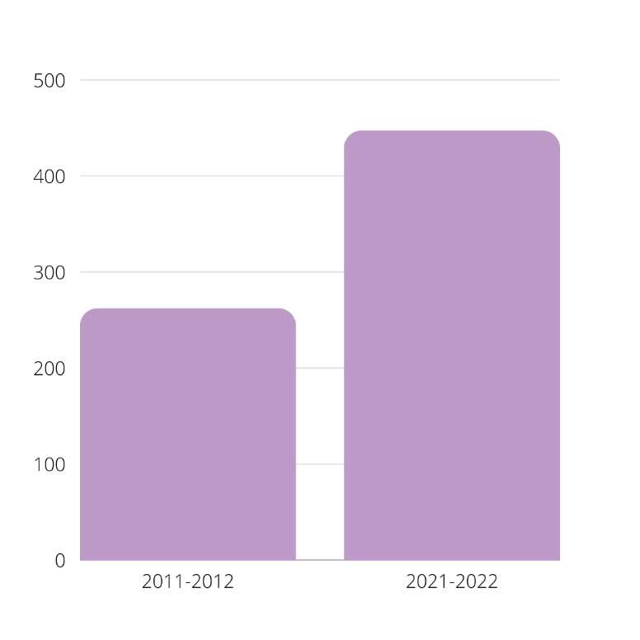
The term “high risk” is used for individuals who are at risk of (victims) or at risk of causing (perpetrators), serious injury and/or homicide. The increase in high risk referrals of 70.6% reflects the growing vulnerabilities of victims (see below) and the changing nature of domestic abuse to include uses of technology for control and surveillance.

Referrals with mental health vulnerabilities.
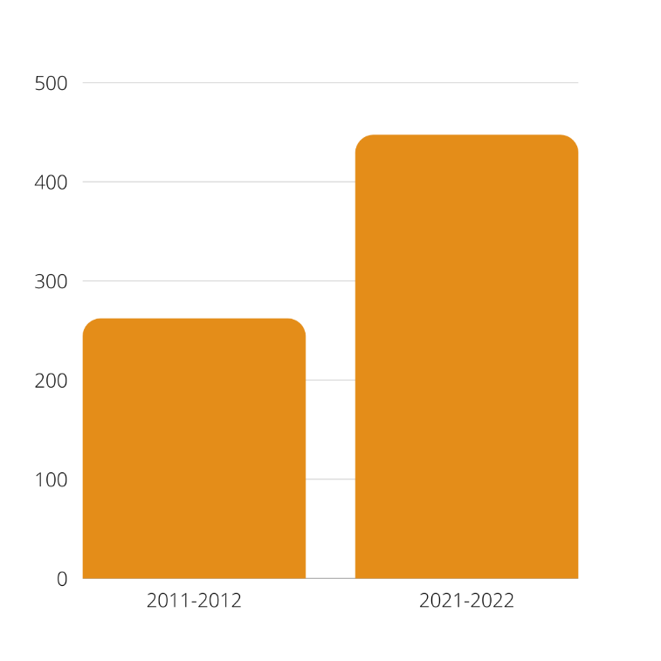

Mental health vulnerabilities amongst clients have grown exponentially over the last decade – an increase of 174%. We comment further on drivers behind these features later in the report.

Sources of referrals
The top three sources of referrals over the decade have remained the same – police, self-referrals and Children & Young People’s Services. Further growth in self-referrals towards the end of this decade reflects the efforts and investment the Wish Centre has made to build its profile and reputation in the media and the community. This is an important driver and is a feature which we return to later in the report.
Which part of the service are individuals referred to

Victim programmes (e.g. AIM and Recovery Toolkit) have been a consistent and core intervention maintained by the Wish Centre throughout, also coping with the need to convert delivery via remote IT during the peaks of the pandemic. . Victim programme referrals were 363% higher in 2021 compared with 2015 levels.

The referrals to our IDVA service, the team who address the safety of victims at high risk of harm and work in a multi-agency way to secure their safety and the safety of their children, saw an increase of 33% in referrals over the decade.

Children’s programmes referrals have also grown considerably, by 792%. Being funded largely by competitive bids to charitable trusts and foundations. The range of programmes available has increased and work has expanded from Blackburn with Darwen to Lancashire wide and Blackpool.

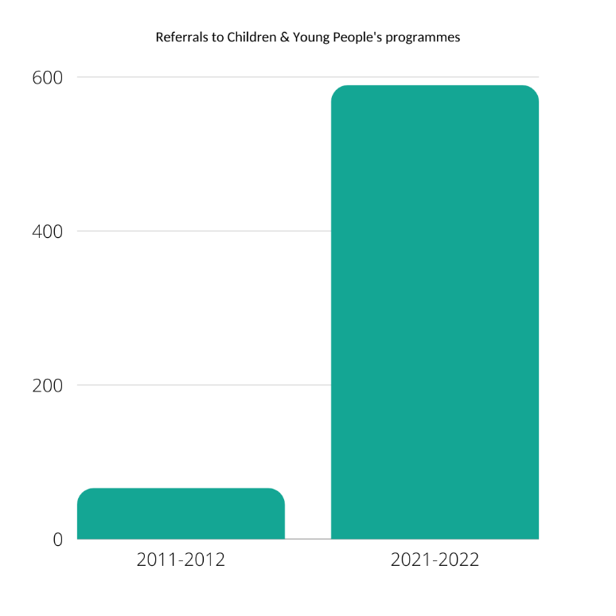

The growth of Perpetrator Programmes and support around behavioural change has also been developed significantly over the decade. At the beginning of the decade our perpetrator work was confined to Blackburn with Darwen but expanded into Lancashire in 2019 and Blackpool in 2021, contributing to the rise in referrals by 605%.

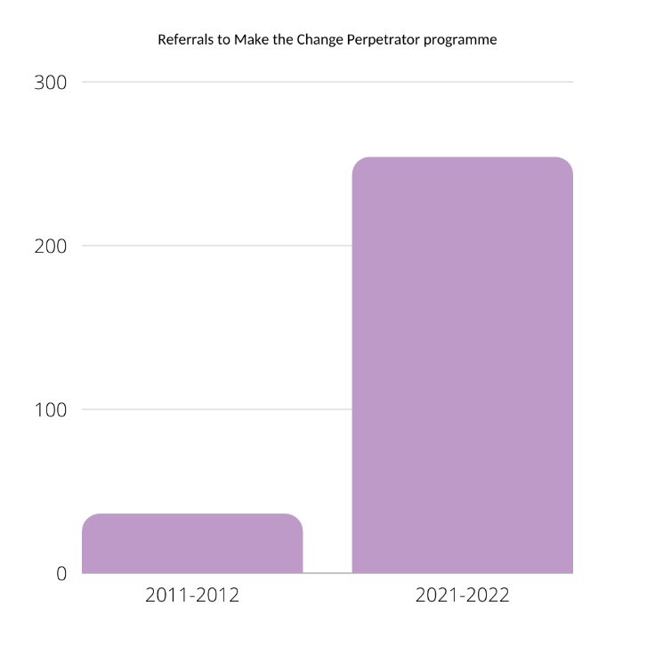

The marked increase in both the children & young people work and the perpetrator work marks a dimensional shift in character for the Wish Centre from a very victim-focused service to one with a whole family approach.

Financial Growth
The performance output data in the line graphs above describe a general growth in the Wish Centre’s capacity over the decade. This is also reflected by healthy financial growth and turnover during this time.

Income figures are taken from the Annual Report and Accounts filed with the Charity Commission and Companies House during the last 6 years, showing significant turnover growth of 126% over this period. We comment further about the drivers behind this income growth later in the report, but the substantive outcomes have been the much greater financial stability and independence which the Wish Centre now enjoys. This has enabled our charity to develop and expand its range of services significantly and extend its reach and impact on the lives of our service users.

- CORPORATE STRENGTHS
A strong corporate culture and identity has underpinned our services. They are enduring strengths which have been vital in the transformation of the organisation, which have made it ever more resilient.
These corporate strengths have been consciously nurtured over the decade.
Getting the culture right
Over the decade the charity has moved to one firmly based on structured, professional planning, becoming much more strategic in its approach to shaping services and addressing need. This has involved a shift away from a “crisis culture” approach which formerly dominated the operational ethos as a whole to one based on calmer analysis and better forward planning. Effective crisis care is still maintained but within the context of a more mature and professional culture.
Operating on a more structured footing has been vital to stability and growth and has provided the right environment for the passion, enthusiasm and commitment of the whole of the Wish Centre team to thrive. This is now part of the body-ethic of the organisation.
Devolved management
This change in culture has also been translated into change to the management structure with the introduction of a devolved middle-management tier which reflects the core areas of business (victim support/IDVAs; perpetrator work; children and young people; and refuge provision) with each area supported by a senior practitioner.
This is a relatively recent change and the team are learning how best to make it work but the immediate benefits have been clear. The changes have freed up time and resources for the small central management team. It can now focus better on more strategic work and priorities. And this at a time when it faces ever-greater demands, along with more staff (the team has doubled to 40 staff members), the testing financial management demands of a larger organisation, along with the associated contractual reporting requirements.
Integration
The creation of a clear middle-management structure has supported integration across the whole team. The organisation has a positive culture and mentality; and interaction and communication between teams happen naturally. There is an “open door” culture where liaison is regularly carried out between victim support and perpetrator workers; between perpetrator workers and refuge and children and young people. As this report testifies, the Wish Centre has grown massively over the last decade in all sorts of aspects:
“It is a massive positive that the Centre can cater for all aspects of DV, especially local people and it’s really good to see how well the various teams operate and mutually support each other’s work.” Staff member
Silo-working is consciously avoided. And liaison occurs informally on a daily basis without waiting for timetabled meetings.
Supportive Board and Chair
As an organisation, the Wish Centre has long enjoyed a positive culture and mentality across the whole staff team. The operational instinct is to acknowledge mistakes but to learn from them and improve – an instinct which is nurtured throughout the organisation. It complements the charity’s emphasis on planning and strategic thinking and has been greatly backed up by a constructive Board of Trustees, Chair and CEO.
The Board and Chair are very responsive to making sure the needs of service users can be met and will make strenuous efforts to identify resources from reserves if possible. The Chair and Chief Executive have a close working relationship which became even closer during the height of the pandemic and this way of working has continued even while the restrictions and challenges of Covid itself have waned.
This close working relationship has created a natural business protocol and environment in which forthcoming issues can be identified and flagged up before they become a problem.
“We can tackle problems early rather than confront the Board with them out of the blue.”
This has helped productive oversight by the Chair and Board along with nurturing productive relationships in the overall running of the service.
Wake-up call
Looking back, one of the most important factors in the successful transformation of the Wish Centre over the last decade was, ironically, the loss of the local commission for DV services by Blackburn with Darwen Council.
“Losing the commission was a massive shock but it did us good. It gave us the jolt that was needed.” Staff member
In 2015 this was the charity’s largest source of funding and most important contract by far. In the middle years of the decade its loss represented an existential threat to the organisation.
The first part of the wake-up call was to accept that we had no divine right to being the local commissioned service, despite our long history and pedigree. Instead we needed to shake our operation up, professionalise our approach and introduce more robust business disciplines. Our will to survive was never in doubt. And similarly the dedication and commitment by our entire staff team to our charitable mission remained throughout.
Diversify our funding base
We did, however, need to diversify our funding base. In a period of about 3 years we scoped out where the gaps in local provision still lay or which needed further investment and development; identified potential funding sources; and started to roll-out a steady programme of funding applications. We invested in some external support to help us do this. Our approaches to funders became more professional, reaching out with applications to would-be investors from government departments, national trusts, charitable foundations and local sources.
You never win everything you apply for (the nature of competitive funding) but the rolling programme of applications was successful overall. It expanded and diversified our funding base with a mix of short term one-year projects along with a number of larger 3-year programmes of activity. These significantly enriched and helped develop our DV provision across all areas of the charity in a challenging period for us. We were able to sustain our team and continue with our mission. These efforts were then rewarded with a successful tender and return of the Blackburn with Darwen Council commission for DV services in 2019; soon followed by the transformative commission for perpetrator services from Lancashire County Council across the whole of the county.
Status as the commissioned service once again has been crucial for the stability and further growth of Wish Centre. Funding from central government (Home Office) during the height of the pandemic in 2020-21 tended to be more directed to commissioned services across the country and we were well-positioned to attract these vital resources. This was reinforced by our efforts to develop positive working relationships both with our local authorities in the North West and the Lancashire Office of the Police and Crime Commissioner, in particular.
Taken together, our efforts to diversify our resource base have given us more confidence, security, more independence and the freedom to operate and innovate.
Cultivating external relationships
Stability, growth and the quality of service are not just based on finance. The continuing development of the Wish Centre has also been the result of our conscious efforts to build relationships with key organisations and groups, both locally and further afield nationally.
Those efforts collectively have helped with our profile and positioning. They have also enabled us to contribute further to the promotion of DV causes and interests, to assist other organisations in their own efforts to respond to DV issues and the needs of those affected by DV; and to influence positive change in the sector as a whole.
Locally, we have very good relationships with our unitary council, Lancashire County Council and the OPCC. We also cover a range of strategic meetings. On our patch these include the Pan Lancs Domestic Abuse Strategic Board; Blackburn with Darwen Domestic Abuse Strategy Group; Perpetrator Strategy group; Blackburn with Darwen Safeguarding Adult Board Meeting; Safe Guarding Adults Board - complex vulnerabilities sub-group; Changing Futures Strategic group meetings; CADS strategic group; Pan Lancashire DHR group; and the Female Offending Board.
Other forums we attend include the Respect accredited members forum; Lancashire Domestic Abuse forum; PCN meetings; MARAC and MAPPA meetings; Transforming Lives Panel; Vulnerable People lived experience group; Serious case review and domestic homicide review meetings; and the Pan Lancashire VCSFE Leadership group.
Connection and participation in such groups is another way we can fulfil our DV objectives. It enables us to raise concerns with statutory services about DV issues. We see this as a day-to-day role and responsibility associated with working in partnership with other agencies and being in a position to hold them to account. We are also able to help major local statutory bodies with advice and data where possible.
Nationally, we believe it has been important to put time and energy into participation in regional and national meetings, initiatives, surveys and consultations. In this way we can reflect local concerns on a bigger platform. It is time well-invested.
The links we have made have all helped with making important connections and raising the Wish Centre’s positive profile. This is not because we have more time than anyone else to network and participate in this way but because it has always been part of our model of working:
“It’s important in our sector for us as a grass roots delivery organisation to lobby for issues and concerns. If you don’t state your opinion, you can’t complain afterwards.” Staff member
One of the Wish Centre’s key organisational strengths is how we both respond to need and to adapt our services accordingly; or where we are unable to do this, then to highlight the gaps to commissioners, partners and funders.
A strong investment in staff
We have always had a strong staff team with good experience, qualifications and commitment. This has also been reflected traditionally in good retention rates. The team has grown in the last few years and the developing needs of our organisation have required even further investment to overcome skills shortages in the sector as a whole.
Common with the rest of the sector, we have recently struggled often to find the right candidates with the right qualifications and direct skills. To address this recruitment problem we have made a conscious decision to identify recruits with transferable skills and invest more heavily in a revamped training programme.
We now have an overhauled and in-depth induction programme with concentrated DV content and awareness raising. This is completed over several days, supported with strong oversight of cases by a senior member of staff. So we now have a bigger team, mentored and supported, recruited from a wider pool of complementary disciplines and taught DV content intensively and how to work safely.
We are also keen for staff to be able to gain qualifications in the relevant fields for their roles.
Equally, volunteering has always been a strong and important part of the Wish Centre’s model. While Covid drastically reduced the scope for using volunteers, we are now coming out from these restrictions and have noticed that we are tending to get volunteers who are studying for public service degrees and looking to join the police, for example. We welcome this very much, adding as it will ultimately produce employees elsewhere in the public sector with relevant DA experience. Volunteers still tend to come to us with relevant past experiences of DA.
Since 2017 we have developed a team of 5 student counsellors who have needed 100 hours of practical experience for their degrees, including currently a drama therapist.
PR, social media and fundraising
The transformation of the Wish Centre’s approach to fundraising and social media has also been a symbol of the organisation’s growing professionalism and maturity. The impact of the Covid-19 pandemic and the lockdown restrictions on social contact during 2020-21 meant that our traditional ways of fundraising via community events and conventional collections were no longer possible.
Instead, we massively upgraded the Wish Centre’s profile on social media, freely sharing a whole range of useful, practical information and resources to the general public, to agencies and professionals in the voluntary and statutory sectors and also to interested private sector businesses.
This has gone a long way to professionalising our approach and we have noted how our enhanced social media profile has yielded phenomenal responses from the public and businesses, especially at seasonal “call out” times, Christmas, New Year, Easter etc.
“Our PR social media profile has changed out of all recognition and has really taken off in the last two years.” Staff member
It has also enabled our development of the commercial/corporate market much more effectively. In very recent times we were invited by a local solicitors to run a session on the impact of DA to employers as part of their series of information webinars to their clients. This is currently leading to the development of training packages/handbooks for local employers, support for this from the local Council and interest from a major blue-chip company to train their HR leads and Wellbeing Champions.
We hope to extend this into seeing local private sector businesses establishing their own wellbeing DA champions across the borough and supported by the Wish Centre. We see this as a much more effective and professional way of building relationships locally with a wide range of businesses and organisations. Our PR function has grown accordingly and this is proving a good investment.
Strategically improved quality
These corporate strengths and qualities have helped sustain and grow the Wish Centre over the course of the decade.
Services for victims continue to grow; prevention work through an expanded perpetrator programme has flourished and is being delivered across the geographical county of Lancashire, matching Central Government’s more targeted focus on this area; early investment in work with children and young people has increased significantly, especially in those areas where young people are offending or have the potential to offend.
As part of the expansion of young people’s work, schools work has re-started with more schools engaged with a momentum building of more schools wanting this support; and Operation Encompass working effectively (alerting schools early of incidents of DV in pupils at home); and a refuge service continuing to meet its challenges with dedication and supreme efforts.
Staff expressed confidence in the quality of the work they did.
“There has been a 100% improvement in the quality of service provision over the years. With low staff turnover and high retention rates, staff and volunteers have developed an ever better understanding of DA itself and this feeds into the support we give now.” Staff member
They felt that this confidence in their performance reflected the heightened profile of domestic abuse nationally in recent years. The amount of information on DA in the public and voluntary sphere has grown exponentially in the last 4 or 5 years.
“And all this can’t have failed to have improved the lives of families.” Staff member
Over the course of the decade the Wish Centre has also received a number of awards and validations of its work. These represent a litmus test and confirmation to the ongoing quality and performance standards of the support we provide. Amongst these are Investors in People; Investing in Children; the Garfield Weston Award; GSK Impact Award; Respect accreditation; and Women’s Aid accreditation.
These are hard won and often achieved via time-consuming and rigorous processes covering procedures, policies, performance data and our ongoing development as a charity and service provider. They are rightly difficult and testing, involve blind interviews with staff and are confirmations that the organisation has invested properly in its people and operation. Awards procedures can be yearly or sometimes over 3 year cycles. Accolades such as these undoubtedly add to credibility and provide assurance for funders and commissioners.

- THE FUTURE AND CHALLENGES AHEAD
Celebrating our development, innovations and progress over the last decade does not mean we are blind to the challenges of the future. Real progress has been made across the sector legislatively with the Domestic Abuse Act 2021 and the creation of a statutory definition. Children and young people have been included as victims in the definition which we welcome, and it is hugely important that this has been acknowledged. There is also a concentration on perpetrator work which together endorses our own efforts in these two areas.
Our task in the coming years is to see that local implementation of the Act in its various aspects and phases work well on the ground. We will be alert to issues and problems and lobby accordingly. Immediate worries include the suitability of agencies with relevant experience offering themselves as refuges or safe accommodation for very vulnerable victims; and the lack of provision still for those with no recourse to public funds.
The impact of the Pandemic on our working practices has been a double-edged sword. It has certainly been a catalyst for innovation; changes in working lifestyle have been appreciated by staff; and greater access and reach to service users previously seen as a problem have been definite steps forward. But it has certainly taken its toll on staff.
“Human interaction, being able to see and interpret body language is key in this sector and vital for counselling and peer support.” Staff member
This sometimes affected the conduct of group recovery programmes when delivered online or via smartphone. Working behaviour has gone through a seismic change as a result of Covid and some of these changes and adaptations seem to be “baked in” to working models in different sectors across the country. It looks like Covid is going to be here for a long time, so this is going to be one to watch out for in terms of the impact on service, performance and on staff teams.
“The Wish Centre is a very responsive organisation - its strengths match its growing remit and scale.” Staff member
That said, the progress we have made has been remarkable. The Wish Centre has grown organically from a very small refuge 33 years ago into a “whole family approach” support service, expanding particularly over the last decade with specific expertise and staffed by people largely from the local community.
The challenges will be there in the future and there will be difficulties ahead – there always are. But as a team we can take these on with confidence.

A SURVIVOR’S LETTER
“We recognise heroic efforts that come with a flash and a bang – so prominent that you can’t help but acknowledge them. But I would argue that the most heroic efforts are those orchestrated behind the scenes, that seamlessly stitch a life together without calling attention to themselves. The Wish Centre in Blackburn is a hub of unappreciated heroic acts that I’ve silently witnessed for more than a year.
I am the mother of four young boys – a four-year-old, a three-year-old, and two 18-month-old twins. To say that my hands are full is putting it lightly. I am a candle burning on both ends but you’d never be able to tell. I put on a strong front and it takes a searching eye to recognise when I’m drowning. In July 2017, I left my abusive marriage and travelled a gruelling five hours in a cab from London to Blackburn.
I remember standing before the doors of the Wish Centre. My vision had tunnelled and a deep exhaustion had settled over me. Had I made the right decision? A support worker came forward with a smile – then another, then another. Each took a child, ushered me inside and happily shushed them. I reached the refuge twenty minutes later and was introduced to my new home for a year.
Dignity is a basic human right and I was stripped of it living in an abusive relationship. The people at The Wish Centre, from their trustees, to their support workers, down to their volunteers, are hell-bent on restoring your dignity and they do it in the most respectful, seamless way. Every day was an opportunity for them to help me believe in myself again, and they welcomed these opportunities with open hands.
You see, it’s the little things that matter, that make a difference. It’s the little things that restore a person’s dignity, not the flashes and the bangs. It’s building trust and showing that you care, not because it’s a job, but because you acknowledge the humanity in another.
Then there were the support workers who would come knocking on your door every morning to ask how you were doing. They called it a welfare check, but it was more than that. It was a reminder: ‘I am here and I care if you are alive and functional today. What can I do to help?’
I am not the person I was a year ago. I am stronger, wiser and more confident than I was even before my abusive relationship. I shine and everyone can see it. My children are happy and it is so obvious.
I have no doubt that if the people at the Wish Centre remained unacknowledged, they would continue as before, working tirelessly to restore dignity to the women and children of UK. But I think these unsung heroes merit the attention and thanks of their community for the service they dedicate themselves to everyday. It is my deepest hope that you will agree with me and champion their heroic acts in the manner that they deserve. “

APPENDIX

METHODS
Information and perspectives have been gathered from a cross section of senior managerial staff via telephone and face-to-face interviews using a semi-structured questionnaire. The respondents are experienced practitioners in the domestic violence/abuse (DVA) and related fields and in most cases have been long-time employees of the Wish Centre.

They have all provided valuable insights and perspectives on key features, qualities and developments which the Centre has experienced over the course of the decade.

- Chief Executive Officer
- Operations Manager
- Chair and Trustee
- Refuge Supervisor
- Perpetrator and Programmes Manager
- IDVA (Independent Domestic Violence Advocate) and Victims Support Manager
- Children and Young People’s Work Co-ordinator
- PR, Volunteer and Fundraising Co-ordinator
Key perspectives and issues on the Wish Centre’s journey through the decade and significant features in its development up to the present were gathered on:
- Key stages in growth
- Nature of and the development programmes and support provided
- Improvements in quality and impact
- Management structures and integration
- Innovation
- Changes
- Problems and challenges
Quantitative data has also been gathered from the Wish Centre’s performance monitoring system over a 10 year period on outputs related to referrals and their sources, high risk referrals, children and young people, IDVA referrals, vulnerabilities, and programme referrals.
The report also contains data about financial income growth over the period with figures taken from the annual report and accounts as filed with the Charities Commission and Companies House over this period.

