Welcome to the latest instalment of the WCBCN. This is an opportunity for us to share with you, the referrers, information relating to our perpetrator work monthly – namely the Gateway to Change workshop and the Make the Change programme. This will allow us to share case studies with you, not only on how the programme works, but how important your referrals are to making a difference in the lives of those affected by DA by enabling them the chance to make changes to their behaviours and, ultimately, their lives and the lives of those affected.
Important Updates for February 2024

- Our referral forms have been updated. They have been sent alongside this newsletter.

INFORMATION ON SUBMITTING REFERRALS

We understand that time is precious when supporting people in the work we all do. In order to save you waiting time with referrals, there are a few key bits of information you may need to know.

- There is a distinction between Make the Change and Gateway to Change. Gateway is a 2-session awareness raising workshop and comes with no report on completion. Make the Change is the full perpetrator programme which runs between 16-22 weeks (depending on the outcome of the assessment) which comes with a court accepted report upon completion.

- Make the Change and Gateway to Change are not anger management courses. They are for behaviour change in relation to DA.

- We can only look at referrals relating to DA towards an intimate spouse or ex/current partner.

- It is vitally important to complete the referral forms in as much detail as possible, providing relevant contact details where applicable. This saves time when processing the forms and enables the facilitator to have as clear a picture before going into any assessment.

- If open/known to Family Court/CAFCASS additional information/documentation will be requested.

- Men must acknowledge that their behaviour is or could be classed as abusive and want to change this.

- It is important to know that a referral does not guarantee a place. Acceptance on GTC and MTC is subject to assessment.

Domestic Abuse in the Media

More than 180 people referred to domestic abuse support via community pharmacy scheme.

Over 186 people have been referred to domestic abuse support services by community pharmacists through the 'Ask for ANI' scheme, which allows discreet assistance using the code word 'ANI' at participating pharmacies. Reporting voluntary, the scheme is also being piloted in job centre sites, with over 4,000 community pharmacies, including 2,300 Boots pharmacies, involved. Additionally, 'Ask for ANI' was accessed over 35 times between January and March 2021.

This initiative complements Hestia's 'UK Says No More' safe space service, utilising pharmacy consultation rooms for support. Claire Anderson, president of the Royal Pharmaceutical Society says it highlights the vital role of pharmacists in aiding those in need and encourages more participation in the scheme as the low figure may not be wholly accurate and be far greater than expected due to non-disclosure by pharmacists.

Council cutbacks leading to an increase in domestic abuse related deaths.

The rise in domestic abuse victims dying due to council cutbacks reflects a troubling trend exacerbated by resource shortages. That’s the stark warning from the Domestic Abuse Commissioner for England and Wales, Nicole Jacobs. Nicole has written to Communities Secretary Michael Gove calling for urgent action. With reduced funding for vital support services, including shelters and counselling, victims find themselves without the necessary assistance to escape abusive situations. Without government support, locals DA services may very well disappear, she believes.

The lack of readily available help and refuge options leaves many trapped in dangerous environments, leading to tragic outcomes. 61% of refuge referrals were rejected in the previous year. Council cutbacks not only limit access to immediate safety but also hinder long-term recovery and prevention efforts. Nicole states that urgent action is imperative to address this crisis and ensure that vulnerable individuals receive the support they desperately need to break free from abusive cycles and prevent further loss of life. She has urged for a legal duty to be included in the Victims and Prisoners Bill to ensure more is done to help.

Domestic Abuse in the Media

Fatal domestic abuse reviews renamed to better recognise suicide cases.

The government is enhancing its response to domestic abuse by broadening the scope of reviews conducted after fatal cases to include suicide, coercive control, and economic abuse. Following a public consultation, the government is amending the law to ensure that Domestic Homicide Reviews can be initiated whenever a death results from domestic abuse, aligning with the Domestic Abuse Act 2021. These reviews, now renamed as 'Domestic Abuse Related Death Reviews', will encompass all forms of abuse, aiding in the learning of lessons from such tragedies.

Minister Laura Farris emphasized the importance of recognizing victims of domestic abuse-related suicide and highlighted the revisions as a step toward saving lives. Domestic Homicide Reviews, now expanded in scope, aim to prevent further tragedies by identifying and implementing lessons learned. The changes follow concerns raised by charities and bereaved families and will be incorporated into law through an amendment to the Victims and Prisoners Bill.

Laura Farris said: “This government has made significant progress addressing fatal domestic abuse, including through our landmark Domestic Abuse Act. However, there is more to do, and we also need to focus on hidden victims who die from domestic abuse related suicide. These changes will enable agencies to contextualise these horrific offences even if the domestic abuse was not physical in nature, better identify the warnings signs and, save lives.”

News From Around the World – Canada

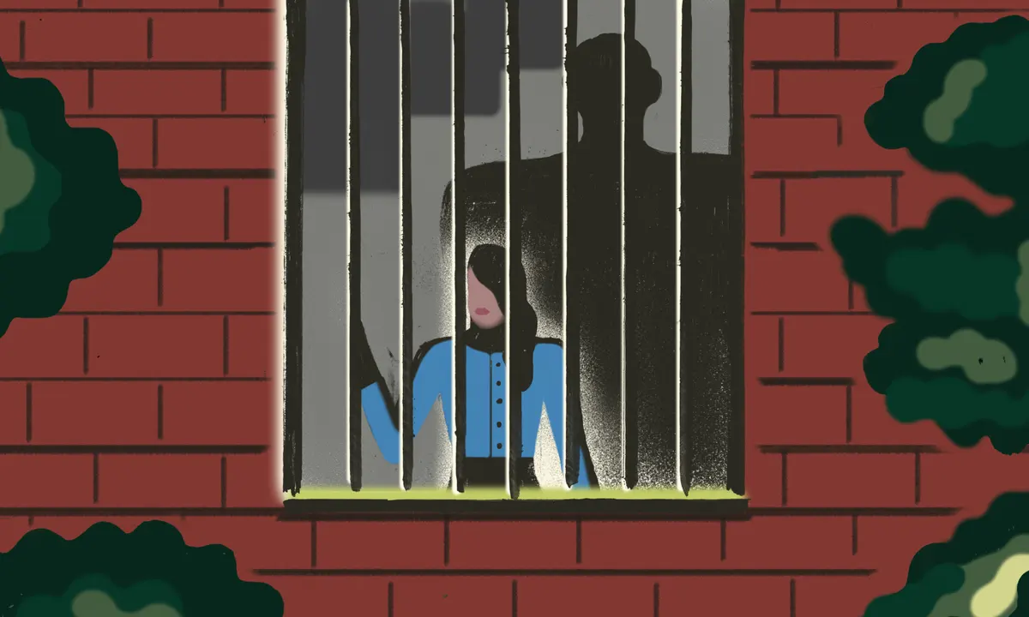

According to recently revealed figures by Statistics Canada, between 2009 and 2022, 18 per cent of solved homicide victims were killed by an intimate partner. This serves to highlight a DA epidemic in Canada, say DA services.
Forty-six per cent of solved homicides of women and girls were perpetrated by an intimate partner, compared to just six per cent of solved homicides of men and boys. The figures also highlight that it is people from minority backgrounds who are at a higher risk.

“We know that it is especially worse for those who are marginalized. I am thinking Indigenous women, racialized women to us, LGBTQ-plus people (including gay men), women with disabilities. The rates are far higher for these communities,” said Lisa Fast from women’s shelter organisation, Steinbach.
Make the Change Case Study

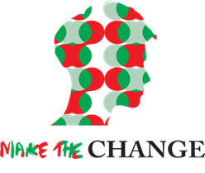

Programme completed in January 2024

Male A was referred to the Make the Change Programme by a Family Support Worker who was working with the male, his ex-partner, and their children.

Male A was assessed and showed acknowledgement of some of his behaviours and stated that he would really like to change these behaviours going forwards. His main reason for wanting to change his negative behaviours was to be able to co-parent better with his ex-partner and to be able to be a better role model to his children.

Male A took part in the Make the Change programme in a small group setting. During the initial couple of sessions, we discussed what Male A’s hopes were from the programme. Male A stated he hoped to be a good dad, change how he used to be and be a gentleman. Male A also shared that he was originally from Afghanistan, and he wants to understand cultural differences in the UK - men/ women and family.

During the sessions Male A was open about suffering from anxiety and taking medication to try and help with this. Throughout the sessions Male A reflected on how having an open, safe space to discuss this with us as facilitators and amongst peers was proving extremely useful to him, not just in relation to his behaviours in relationships but in relation to his anxiety in general which was extremely positive.

We discussed stresses, trigger points, and coping strategies and attitudes and views of women and men in society, families, and children and what the expectations were. Male A stated he learnt a lot from this, and came back over the following weeks to say that he had put these views into practice, starting with addressing ‘toxic masculinity views’ from his colleagues and challenging them, and also by communicating with his ex-partner who is the mother of his children and expressing his appreciation for her as a mother and a woman, and understood that he could express this to her and show he was grateful for all she did. He referred to her as an ‘amazing mother’ and said she did a wonderful job with the children and that he admired how hard she worked to be an independent woman and mother and was appreciative of how supportive she was of the relationship he had with his children, as she actively encouraged Male A to be as involved as he could be in the children’s lives, which Male A was.

Male A had never been educated on the law by his own account, and one of the subject matters covered within the programme is the law in the UK regarding sexual offences. Male A was shocked to learn of what constituted sexual harassment/sexual assault and whilst he had an understanding that these things were wrong, he did not know they carried potential charges and custodial sentences. This is something again, he then challenged when witnessed (he witnessed catcalling of a woman in the street and challenged the male responsible).

We also discussed Adverse Childhood Experiences (ACE’s) – those of Male A himself, and those of his children from witnessing domestic abuse even at their young ages (all were under 5 during the relationship of Male A and his ex-partner). Male A could correlate how his ACE’s impacted his thought processes/beliefs/behaviours but understood these were not a ‘rationale’ for his behaviours. He also understood the severe impact on his children that could occur from witnessing domestic abuse at any age.

Later, towards the end of the programme, we ask each male to reflect on an incident of domestic abuse, whereby they are the perpetrator. We then create a ‘story board’ of this incident from start to finish and look at what it looked like at the time and how it would be different now. Male A reflected very honestly about a violent incident whereby he had physically assaulted his ex-partner. By his own account he recalled she had not done anything wrong and had simply confronted him about behaviours he had shown and his treatment of her following the arrival of their youngest child. He reflected on his thoughts, feelings, emotions, and actions of this incident, and showed an understanding, a sincere remorse, and was able to suggest numerous better ways to respond to the situation, inclusive of safe and effective communication methods/time outs.

Male A completed the programme reporting a significant change in understanding of domestic abuse, the types of domestic abuse, what constitutes abusive behaviour, healthy views of men, women and children in society, the law, and methods of behaviour management such as calm, clear, and effective communication, time outs and safe ways of addressing emotions and feelings.

Throughout, we also contact the ex-partners or partners of males who are on the programme. Male A’s ex-partner was contacted throughout and reported positive outcomes each time, particularly at the end of the programme whereby she reported he was ‘considerably more thoughtful in his decision making regarding the children, he is much more rational in responses if there is a disagreement between them and will hear her out and communicate concerns instead of becoming angry’. This is extremely positive feedback from an ex-partner, they have been separated for a considerable amount of time and she is in a new relationship which Male A is also supportive of and again throughout his learning on the programme expressed that Make the Change had helped him to understand the importance of being supportive of this relationship for the benefit of his children and the co-parenting relationship with his ex-partner.

Karina Bentham
Behaviour Change Programme Manager

Understanding the Role of Behaviour Change Programmes in Tackling Domestic Abuse

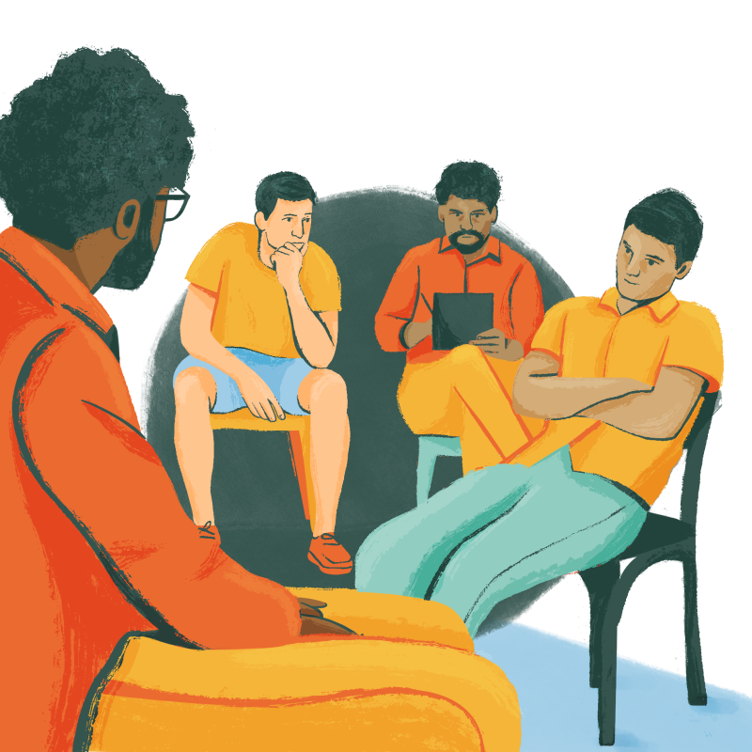

While much attention is rightfully directed towards supporting survivors, it is equally essential to address the root causes of the problem. This is where behaviour change programmes come into play. These programmes offer a unique approach to combating domestic abuse by focusing on the individuals responsible for the abuse. Let us delve deeper into the significance of perpetrator programmes and the impact they can have on breaking the cycle of abuse.

Shifting the Focus to Accountability

Behaviour change programmes operate on the principle of accountability. They recognise that those who perpetrate domestic abuse must take responsibility for their actions. By engaging perpetrators in structured interventions, these programmes provide a space for individuals to confront their behaviour, acknowledge the harm they have caused, and take steps towards change. This shift from blame to accountability is essential in promoting personal growth and preventing future instances of abuse.

Education and Awareness

Central to behaviour change programmes is the provision of education and awareness regarding healthy relationships, boundaries, and consent. Many individuals who engage in abusive behaviour may not fully understand the impact of their actions or the dynamics of power and control within relationships. Through psycho-educational sessions and group therapy, participants in these programmes gain insight into the underlying factors contributing to their behaviour and learn alternative ways of resolving conflicts and expressing emotions.

Addressing Root Causes

Domestic abuse often stems from a combination of factors, including childhood trauma, substance abuse, mental health issues, and learned behaviours. Behaviour change programmes offer comprehensive assessments to identify the root causes of abusive behaviour in each participant. From there, tailored interventions, such as individual counselling or anger management courses, are provided to address these underlying issues effectively. By targeting the root causes of abuse, these programmes aim to break the cycle and promote long-term behavioural change.

Empowering Participants to Make Positive Choices

Participation in a behaviour change programme is not just about fulfilling any kind of legal requirement; it is about empowering individuals to make positive choices in their lives. By providing support, guidance, and resources, these programmes equip participants with the tools they need to lead healthier and more fulfilling lives and relationships going forward. This empowerment extends beyond the individual to their families and communities, as breaking the cycle of abuse benefits everyone involved.
Collaboration and Support

Behaviour change programmes operate within a framework of collaboration and support. They work closely with other agencies, such as police, probation, social services, and victim support organisations, to ensure a holistic approach to addressing domestic abuse. By fostering collaboration among stakeholders, these programmes can provide comprehensive support to both survivors and perpetrators, ultimately leading to more effective outcomes.

Building Safer Communities

At its core, the aim of behaviour change programmes is to create safer communities free from abuse and abuse. By intervening with perpetrators and addressing the root causes of their behaviours, these programmes contribute to breaking the cycle of abuse and promoting a culture of respect and equality. When individuals learn to navigate relationships without resorting to abuse, the entire community benefits from increased safety and cohesion.

Behaviour change programmes, therefore, play a vital role in tackling domestic abuse by holding perpetrators accountable, addressing root causes, and promoting long-term behavioural change.

This is why your referrals into our service are of immense importance.

By investing in Make the Change, you are helping to create a Lancashire where healthy relationships thrive, and abuse is no longer tolerated. It is time to recognise the importance of programmes like Make the Change in creating a safer and more compassionate world for all.

Unveiling the Brutal Reality of Domestic Abuse in
"Nil by Mouth"

Domestic abuse is a harrowing reality that pervades many lives, often lurking behind closed doors and veiled in silence. Gary Oldman's directorial debut, "Nil by Mouth," bravely thrust this issue into the spotlight, offering a raw and unflinching portrayal of its devastating effects on individuals and families. Released in 1997, the film remains a powerful and haunting exploration of the cyclical nature of abuse, the complexities of relationships, and the resilience of the human spirit.

Set in the working-class neighbourhoods of South London, "Nil by Mouth" follows the tumultuous lives of Ray, portrayed by Ray Winstone, and his wife Valerie, played by Kathy Burke. From the film's opening moments, viewers are confronted with the visceral reality of domestic abuse as Ray's explosive temper and unchecked aggression set the tone for the narrative. Through a series of gritty and often uncomfortable scenes, the film delves deep into the dynamics of abuse, laying bare the emotional and physical toll it exacts on its victims.

At the heart of "Nil by Mouth" is Valerie, a woman trapped in a cycle of abuse and despair. Kathy Burke delivers a powerhouse performance, capturing Valerie's vulnerability, resilience, and quiet strength amidst the chaos that engulfs her life. Through her eyes, audiences bear witness to the insidious ways in which abuse can erode one's sense of self-worth and agency, leaving scars that run deeper than any physical injury.

What sets "Nil by Mouth" apart is its unflinching commitment to authenticity. Gary Oldman draws from his own experiences growing up in South London, infusing the film with a gritty realism that is both compelling and confronting. The dialogue crackles with authenticity, capturing the cadences and vernacular of working-class life with remarkable precision. This attention to detail extends to the film's visual language, with cinematographer Ron Fortunato immersing viewers in the claustrophobic confines of Ray and Valerie's world.

Yet, amidst the darkness, "Nil by Mouth" also offers glimpses of hope and humanity. In moments of tenderness and vulnerability, Ray and Valerie share fleeting respites from the brutality of their existence, reminding audiences of the complexity of their relationship. Similarly, supporting characters such as Valerie's brother Billy and her mother Janet provide rays of light in an otherwise bleak landscape, underscoring the resilience of the human spirit in the face of adversity.

"Nil by Mouth" is not an easy film to watch. It confronts viewers with uncomfortable truths and challenges them to confront the realities of domestic abuse with unflinching honesty. Yet, it is precisely this unvarnished honesty that makes the film so powerful and essential. By shining a light on the dark corners of society that many would prefer to ignore, "Nil by Mouth" forces us to reckon with the human cost of abuse and the urgent need for empathy, understanding, and intervention.

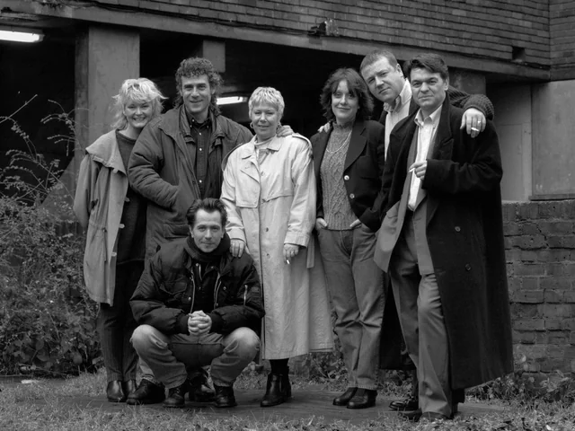

In the years since its release, "Nil by Mouth" has rightfully earned its place as a seminal work in the canon of films addressing domestic abuse. Its uncompromising vision, coupled with standout performances and masterful direction, ensures that its impact will be felt for generations to come. As we continue to grapple with the pervasive scourge of domestic abuse, "Nil by Mouth" stands as a stark reminder of the importance of bearing witness to the stories of survivors and amplifying their voices in the pursuit of justice and healing.

'Can I Tell You a Secret?' and the Dilemma of Women Not Being Believed

In a world where truth often struggles to find its footing amidst scepticism and bias, the Netflix documentary "Can I Tell You a Secret?" shines a spotlight on a particularly poignant issue: the pervasive disbelief faced by women when they bravely come forward with their experiences. Directed by acclaimed filmmaker Ava Thompson, the documentary delves deep into the unsettling reality of stalking and incessant harassment that many women encounter and the injustice they face when they seek validation and justice for their truths.

The documentary weaves together the narratives of several women from different backgrounds, each sharing their stories of trauma and abuse at the hands of Matthew Hardy, and the harrowing journey of having their lives destroyed. The documentary lays bare their raw emotions and the challenges these women grappled with as they navigated a world that failed to acknowledge their truth.

At the heart of "Can I Tell You a Secret?" lies a crucial question: Why are women so frequently met with disbelief when they muster the courage to speak out? The documentary examines in emotional detail the implication of disbelief, discrediting and systemic factors on the victims that contribute to this alarming phenomenon, as shown within the police. While it does not succeed in challenging ingrained gender stereotypes and biases that cast doubt on women's credibility (more could have been done about this), portraying how these prejudices can seep into services meant to protect is still very disturbing.

One of the documentary's most powerful elements is its exploration of the psychological toll of not being believed. For many women, the experience of being dismissed or invalidated amplifies their trauma, leaving them feeling isolated, silenced, and powerless. "Can I Tell You a Secret?" poignantly captures the emotional anguish and resilience of these women as they grapple with the aftermath of not being heard, having their characters assassinated and having their relationships with partners, close friends, work colleagues, and family members cruelly destroyed. Even more frightful is the police assertion that they cannot do anything to help unless they are in immediate harm or risk. That being physically hurt is the only way to access support.

Moreover, the documentary sheds light on the broader implications of disbelief, highlighting how it perpetuates a culture of silence and impunity. When women are consistently discredited or met with scepticism, it emboldens perpetrators and perpetuates cycles of abuse and injustice. The documentary clearly shows that there is work that needs to be done within the police as to how they handle women’s genuine concerns for their safety. Women who utilise social media are often unfairly scrutinised and even discredited based on their online presence, perpetuating victim-blaming narratives.

By amplifying the voices of survivors and challenging societal norms, "Can I Tell You a Secret?" underscores the urgent need for empathy, support, and systemic change.

Importantly, the documentary also celebrates the courage and strength of women who refuse to be silenced. Through their resilience and determination, they reclaim their narratives, empower others to speak their truths, and advocate for meaningful change. "Can I Tell You a Secret?" serves as a powerful call to action, urging viewers to confront their own biases, support survivors, and work towards building a more just and inclusive society.

As the documentary ends and the impact of "Can I Tell You a Secret?" lingers, viewers are left with a profound sense of introspection. The documentary serves as a poignant reminder that believing women is not just a moral imperative but a fundamental step towards creating a world where victims feel safe and protected by the services that are meant to do that and that truth is valued, justice is served, and survivors are no longer forced to suffer in silence. It also highlights the precarious nature of social media and the need for more personal privacy. It is a testament to the enduring power of storytelling in not only telling the truth but in shaping hearts, minds, and societies.

End of Programme Participation Feedback - AM

What has been your main learning from attending the Make the Change programme?
The cup of tea video on consent as this was the area I wanted to learn more about.

Do you feel you have a better understanding and control of your own feelings?
Yes, I do.

Do you feel you have a better understanding of other people’s feelings and perspectives?
Yes, I do.

What do you hope to achieve in future relationships?
I will hopefully rebuild my marriage and the trust with my wife and be the person she deserves to be with and not have the children worried or without me.
I want them all to be happy.

How do you feel about the victim now you have completed the programme?
I still think she is an amazing mum and woman and mother.

Can you identify any of your belief system that has been challenged on the programme?
I think the mentality of because she’s done something to me its fine to do it back and it is not at all.

What was difficult for you on the programme?
Going back through what I did and looking at how it has affected the kids, my partner and everyone around me.

Please do continue to send referrals for GTC/MTC to info@thewishcentre.org

